# **Assignment - 2**

# **Data Visualization and Pre-processing**

| Assignment Date | 21 September 2022 |
| --- | --- |
| Student Name | Nesika P |
| Student Roll Number | 921319104134 |
| Maximum Marks | 2 Marks |

import numpy as np  
import pandas as pd  
import seaborn as sns  
import matplotlib.pyplot as plt

# **Load da****taset**

df=pd.read_csv('/content/Churn_Modelling.csv')

df.head()

RowNumber CustomerId Surname CreditScore Geography Gender Age \  
0 1 15634602 Hargrave 619 France Female 42   
1 2 15647311 Hill 608 Spain Female 41   
2 3 15619304 Onio 502 France Female 42   
3 4 15701354 Boni 699 France Female 39   
4 5 15737888 Mitchell 850 Spain Female 43   
  
 Tenure Balance NumOfProducts HasCrCard IsActiveMember \  
0 2 0.00 1 1 1   
1 1 83807.86 1 0 1   
2 8 159660.80 3 1 0   
3 1 0.00 2 0 0   
4 2 125510.82 1 1 1   
  
 EstimatedSalary Exited   
0 101348.88 1   
1 112542.58 0   
2 113931.57 1   
3 93826.63 0   
4 79084.10 0

df.info()

<class 'pandas.core.frame.DataFrame'>  
RangeIndex: 10000 entries, 0 to 9999  
Data columns (total 14 columns):  
 # Column Non-Null Count Dtype   
--- ------ -------------- -----   
 0 RowNumber 10000 non-null int64   
 1 CustomerId 10000 non-null int64   
 2 Surname 10000 non-null object   
 3 CreditScore 10000 non-null int64   
 4 Geography 10000 non-null object   
 5 Gender 10000 non-null object   
 6 Age 10000 non-null int64   
 7 Tenure 10000 non-null int64   
 8 Balance 10000 non-null float64  
 9 NumOfProducts 10000 non-null int64   
 10 HasCrCard 10000 non-null int64   
 11 IsActiveMember 10000 non-null int64   
 12 EstimatedSalary 10000 non-null float64  
 13 Exited 10000 non-null int64   
dtypes: float64(2), int64(9), object(3)  
memory usage: 1.1+ MB

### **Visualisations**

# **1. Univariate Analysis**

df['Gender'].value_counts()

Male 5457  
Female 4543  
Name: Gender, dtype: int64

*# Plotting the features of the dataset to see the correlation between them*  
plt.hist(x = df.Gender, bins = 3, color = 'green')  
plt.title('comparison of male and female')  
plt.xlabel('Gender')  
plt.ylabel('population')  
plt.show()

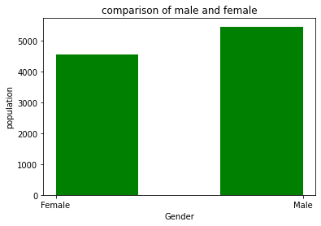

df['Age'].value_counts()

37 478  
38 477  
35 474  
36 456  
34 447  
 ...   
92 2  
82 1  
88 1  
85 1  
83 1  
Name: Age, Length: 70, dtype: int64

*# comparison of age in the dataset*  
  
plt.hist(x = df.Age, bins = 10, color = 'orange')  
plt.title('comparison of Age')  
plt.xlabel('Age')  
plt.ylabel('population')  
plt.show()

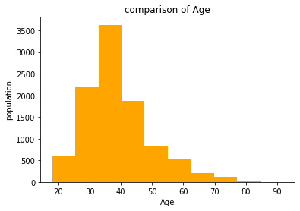

df['Geography'].value_counts()

France 5014  
Germany 2509  
Spain 2477  
Name: Geography, dtype: int64

*# comparison of geography*  
  
plt.hist(x = df.Geography, bins = 5, color = 'blue')  
plt.title('comparison of Geography')  
plt.xlabel('Geography')  
plt.ylabel('population')  
plt.show()

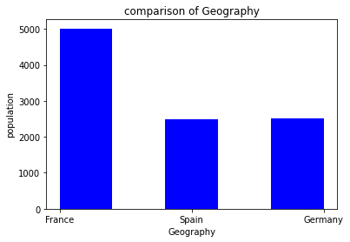

df['HasCrCard'].value_counts()

1 7055  
0 2945  
Name: HasCrCard, dtype: int64

*# comparision of how many customers hold the credit card*  
  
plt.hist(x = df.HasCrCard, bins = 3, color = 'violet')  
plt.title('how many people have or not have the credit card')  
plt.xlabel('customers holding credit card')  
plt.ylabel('population')  
plt.show()

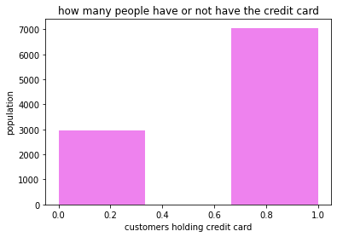

df['IsActiveMember'].value_counts()

1 5151  
0 4849  
Name: IsActiveMember, dtype: int64

*# How many active member does the bank have ?*  
  
plt.hist(x = df.IsActiveMember, bins = 3, color = 'brown')  
plt.title('Active Members')  
plt.xlabel('Customers')  
plt.ylabel('population')  
plt.show()

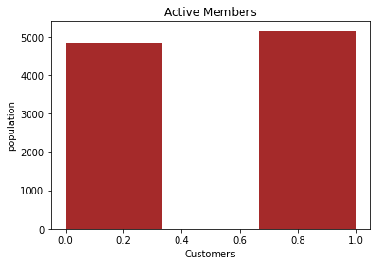

# **2. Bi - Variate Analysis**

*# comparison between Geography and Gender*  
  
Gender = pd.crosstab(df['Gender'],df['Geography'])  
Gender.div(Gender.sum(1).astype(float), axis=0).plot(kind="bar", stacked=True, figsize=(6, 6))

<matplotlib.axes._subplots.AxesSubplot at 0x7f0f0d4da990>

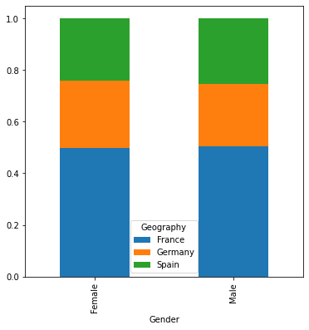

*# comparison between geography and card holders*  
  
HasCrCard = pd.crosstab(df['HasCrCard'], df['Geography'])  
HasCrCard.div(HasCrCard.sum(1).astype(float), axis = 0).plot(kind = 'bar',  
 stacked = True,figsize = (6, 6))

<matplotlib.axes._subplots.AxesSubplot at 0x7f0f0d40bb90>

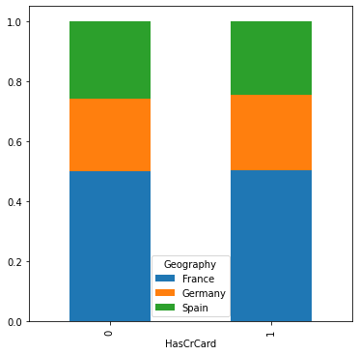

*# comparison of active member in differnt geographies*  
  
IsActiveMember = pd.crosstab(df['IsActiveMember'], df['Geography'])  
IsActiveMember.div(IsActiveMember.sum(1).astype(float), axis = 0).plot(kind = 'bar',   
 stacked = True, figsize= (6, 6))

<matplotlib.axes._subplots.AxesSubplot at 0x7f0f0d394110>

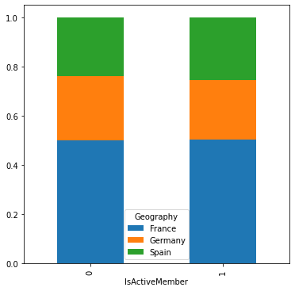

*# comparing ages in different geographies*  
  
Age = pd.crosstab(df['Age'], df['Geography'])  
Age.div(Age.sum(1).astype(float), axis = 0).plot(kind = 'bar',   
 stacked = True, figsize = (15,15))

<matplotlib.axes._subplots.AxesSubplot at 0x7f0f0d326690>

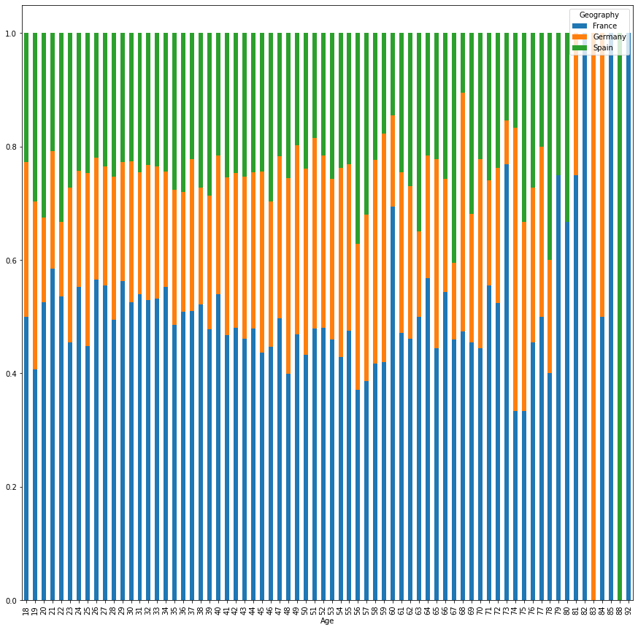

*# calculating total balance in france, germany and spain*  
  
total_france = df.Balance[df.Geography == 'France'].sum()  
total_germany = df.Balance[df.Geography == 'Germany'].sum()  
total_spain = df.Balance[df.Geography == 'Spain'].sum()  
  
print("Total Balance in France :",total_france)  
print("Total Balance in Germany :",total_germany)  
print("Total Balance in Spain :",total_spain)

Total Balance in France : 311332479.49  
Total Balance in Germany : 300402861.38  
Total Balance in Spain : 153123552.01

*# plotting a pie chart*  
  
labels = 'France', 'Germany', 'Spain'  
colors = ['cyan', 'magenta', 'orange']  
sizes = [311, 300, 153]  
explode = [ 0.01, 0.01, 0.01]  
  
plt.pie(sizes, colors = colors, labels = labels, explode = explode, shadow = True)  
  
plt.axis('equal')  
plt.show()

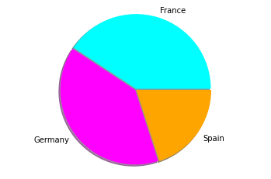

# **3. Multi - Variate Analysis**

sns.pairplot(data=df, hue='Exited')

<seaborn.axisgrid.PairGrid at 0x7f0f0d201290>

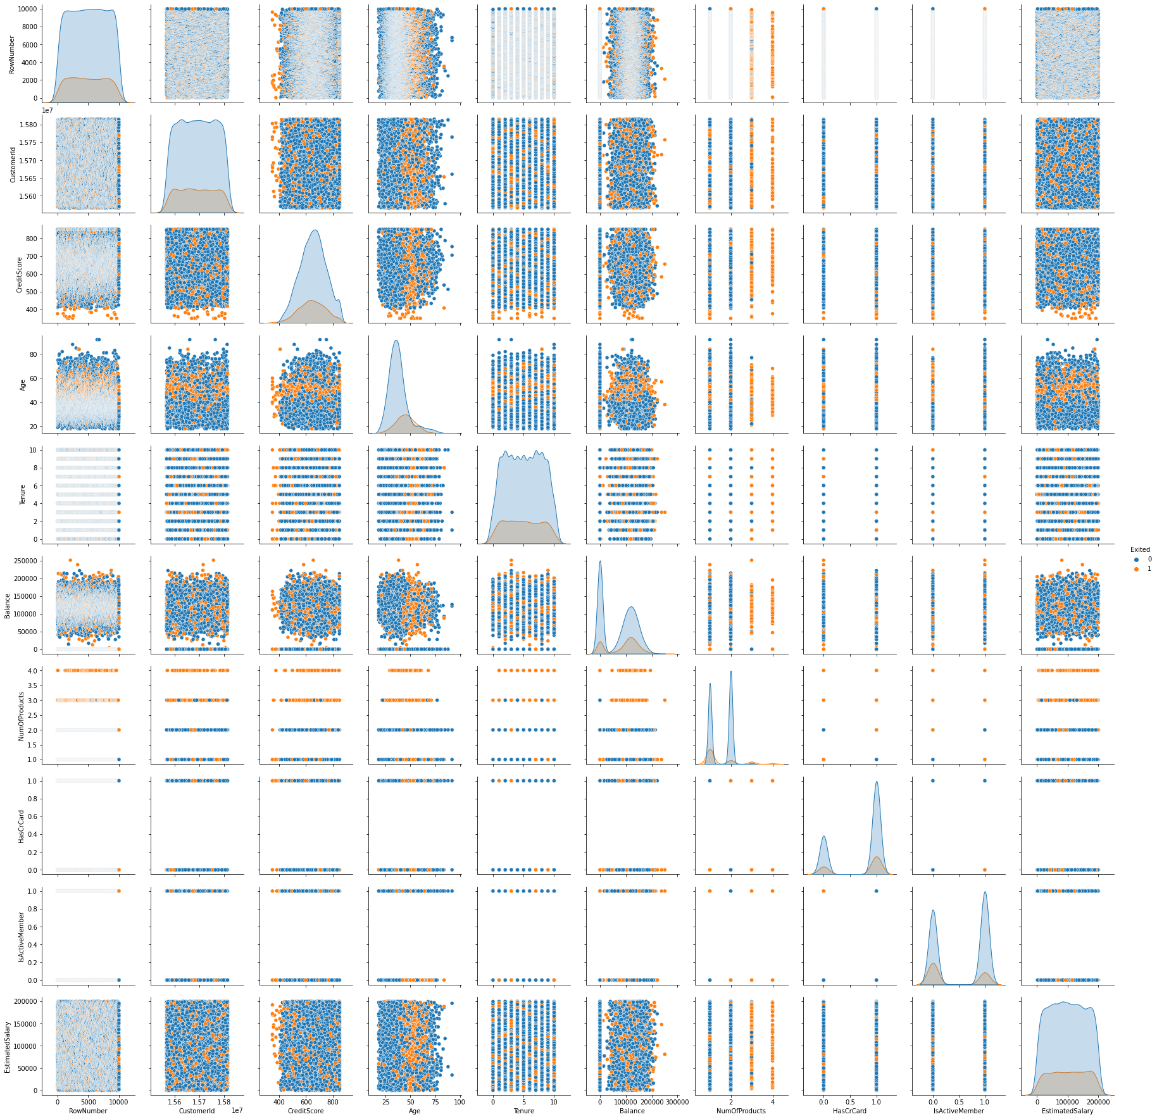

# **Descriptive statistics**

df.describe()

RowNumber CustomerId CreditScore Age Tenure \  
count 10000.00000 1.000000e+04 10000.000000 10000.000000 10000.000000   
mean 5000.50000 1.569094e+07 650.528800 38.921800 5.012800   
std 2886.89568 7.193619e+04 96.653299 10.487806 2.892174   
min 1.00000 1.556570e+07 350.000000 18.000000 0.000000   
25% 2500.75000 1.562853e+07 584.000000 32.000000 3.000000   
50% 5000.50000 1.569074e+07 652.000000 37.000000 5.000000   
75% 7500.25000 1.575323e+07 718.000000 44.000000 7.000000   
max 10000.00000 1.581569e+07 850.000000 92.000000 10.000000   
  
 Balance NumOfProducts HasCrCard IsActiveMember \  
count 10000.000000 10000.000000 10000.00000 10000.000000   
mean 76485.889288 1.530200 0.70550 0.515100   
std 62397.405202 0.581654 0.45584 0.499797   
min 0.000000 1.000000 0.00000 0.000000   
25% 0.000000 1.000000 0.00000 0.000000   
50% 97198.540000 1.000000 1.00000 1.000000   
75% 127644.240000 2.000000 1.00000 1.000000   
max 250898.090000 4.000000 1.00000 1.000000   
  
 EstimatedSalary Exited   
count 10000.000000 10000.000000   
mean 100090.239881 0.203700   
std 57510.492818 0.402769   
min 11.580000 0.000000   
25% 51002.110000 0.000000   
50% 100193.915000 0.000000   
75% 149388.247500 0.000000   
max 199992.480000 1.000000

# **Handle t****he Missing values**

df.isnull().sum()

RowNumber 0  
CustomerId 0  
Surname 0  
CreditScore 0  
Geography 0  
Gender 0  
Age 0  
Tenure 0  
Balance 0  
NumOfProducts 0  
HasCrCard 0  
IsActiveMember 0  
EstimatedSalary 0  
Exited 0  
dtype: int64

# **Find the outliers and replace t****he outliers**

sns.boxplot(data = df, x = 'CreditScore')

<matplotlib.axes._subplots.AxesSubplot at 0x7f0f081e7490>

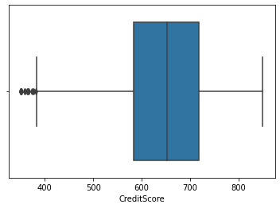

sns.boxplot(data = df, x = 'Age')

<matplotlib.axes._subplots.AxesSubplot at 0x7f0f082306d0>

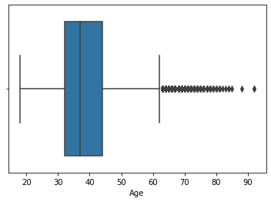

sns.boxplot(data = df, x = 'Balance')

<matplotlib.axes._subplots.AxesSubplot at 0x7f0f08f8d850>

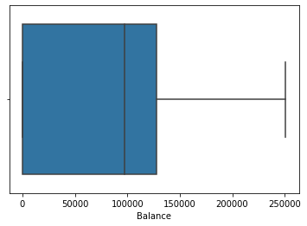

sns.boxplot(data = df, x = 'EstimatedSalary')

**for** i **in** df:  
 **if** df[i].dtype=='int64' **or** df[i].dtypes=='float64':  
 q1=df[i].quantile(0.25)  
 q3=df[i].quantile(0.75)  
 iqr=q3-q1  
 upper=q3+1.5*iqr  
 lower=q1-1.5*iqr  
 df[i]=np.where(df[i] >upper, upper, df[i])  
 df[i]=np.where(df[i] <lower, lower, df[i])

df.describe()

RowNumber CustomerId CreditScore Age Tenure \  
count 10000.00000 1.000000e+04 10000.000000 10000.000000 10000.000000   
mean 5000.50000 1.569094e+07 650.561300 38.660800 5.012800   
std 2886.89568 7.193619e+04 96.558702 9.746704 2.892174   
min 1.00000 1.556570e+07 383.000000 18.000000 0.000000   
25% 2500.75000 1.562853e+07 584.000000 32.000000 3.000000   
50% 5000.50000 1.569074e+07 652.000000 37.000000 5.000000   
75% 7500.25000 1.575323e+07 718.000000 44.000000 7.000000   
max 10000.00000 1.581569e+07 850.000000 62.000000 10.000000   
  
 Balance NumOfProducts HasCrCard IsActiveMember \  
count 10000.000000 10000.000000 10000.00000 10000.000000   
mean 76485.889288 1.527200 0.70550 0.515100   
std 62397.405202 0.570081 0.45584 0.499797   
min 0.000000 1.000000 0.00000 0.000000   
25% 0.000000 1.000000 0.00000 0.000000   
50% 97198.540000 1.000000 1.00000 1.000000   
75% 127644.240000 2.000000 1.00000 1.000000   
max 250898.090000 3.500000 1.00000 1.000000   
  
 EstimatedSalary Exited   
count 10000.000000 10000.0   
mean 100090.239881 0.0   
std 57510.492818 0.0   
min 11.580000 0.0   
25% 51002.110000 0.0   
50% 100193.915000 0.0   
75% 149388.247500 0.0   
max 199992.480000 0.0

# **Preprocessing**

*# Removing the unnecassary features from the dataset*  
  
data = df.drop(['CustomerId', 'Surname', 'RowNumber'], axis = 1)  
  
print(df.columns)

Index(['RowNumber', 'CustomerId', 'Surname', 'CreditScore', 'Geography',  
 'Gender', 'Age', 'Tenure', 'Balance', 'NumOfProducts', 'HasCrCard',  
 'IsActiveMember', 'EstimatedSalary', 'Exited'],  
 dtype='object')

data.shape

(10000, 11)

# **Split t****he data into dependent and independent variables**

*# splitting the dataset into x(independent variables) and y(dependent variables)*  
  
x = df.iloc[:,0:10]  
y = df.iloc[:,10]  
  
print(x.shape)  
print(y.shape)  
  
print(x.columns)

(10000, 10)  
(10000,)  
Index(['RowNumber', 'CustomerId', 'Surname', 'CreditScore', 'Geography',  
 'Gender', 'Age', 'Tenure', 'Balance', 'NumOfProducts'],  
 dtype='object')

# **Check for Categorical columns and perform encoding**

x = pd.get_dummies(x)  
  
x.head()

RowNumber CustomerId CreditScore Age Tenure Balance NumOfProducts \  
0 1.0 15634602.0 619.0 42.0 2.0 0.00 1.0   
1 2.0 15647311.0 608.0 41.0 1.0 83807.86 1.0   
2 3.0 15619304.0 502.0 42.0 8.0 159660.80 3.0   
3 4.0 15701354.0 699.0 39.0 1.0 0.00 2.0   
4 5.0 15737888.0 850.0 43.0 2.0 125510.82 1.0   
  
 Surname_Abazu Surname_Abbie Surname_Abbott ... Surname_Zubarev \  
0 0 0 0 ... 0   
1 0 0 0 ... 0   
2 0 0 0 ... 0   
3 0 0 0 ... 0   
4 0 0 0 ... 0   
  
 Surname_Zubareva Surname_Zuev Surname_Zuyev Surname_Zuyeva \  
0 0 0 0 0   
1 0 0 0 0   
2 0 0 0 0   
3 0 0 0 0   
4 0 0 0 0   
  
 Geography_France Geography_Germany Geography_Spain Gender_Female \  
0 1 0 0 1   
1 0 0 1 1   
2 1 0 0 1   
3 1 0 0 1   
4 0 0 1 1   
  
 Gender_Male   
0 0   
1 0   
2 0   
3 0   
4 0   
  
[5 rows x 2944 columns]

# **Scale the independent variables**

from sklearn.preprocessing import StandardScaler  
  
sc = StandardScaler()  
x_train = sc.fit_transform(x_train)  
x_test = sc.fit_transform(x_test)  
  
x_train = pd.DataFrame(x_train)  
x_train.head()

0 1 2 3 4 5 6 \  
0 -0.702176 -1.343330 -0.736828 0.042283 0.008860 0.673160 2.583231   
1 -1.485722 1.558330 1.025257 -0.674496 0.008860 -1.207724 0.822578   
2 -0.524522 -0.655156 0.808861 -0.469702 1.393293 -0.356937 0.822578   
3 -1.167396 1.200594 0.396677 -0.060114 0.008860 -0.009356 -0.938076   
4 -1.451159 0.778798 -0.468908 1.373444 0.701077 -1.207724 0.822578   
  
 7 8 9 ... 2934 2935 2936 2937 2938 \  
0 -0.016332 0.0 -0.0231 ... -0.011548 0.0 -0.011548 -0.011548 -0.016332   
1 -0.016332 0.0 -0.0231 ... -0.011548 0.0 -0.011548 -0.011548 -0.016332   
2 -0.016332 0.0 -0.0231 ... -0.011548 0.0 -0.011548 -0.011548 -0.016332   
3 -0.016332 0.0 -0.0231 ... -0.011548 0.0 -0.011548 -0.011548 -0.016332   
4 -0.016332 0.0 -0.0231 ... -0.011548 0.0 -0.011548 -0.011548 -0.016332   
  
 2939 2940 2941 2942 2943   
0 -1.015588 1.760216 -0.574682 1.087261 -1.087261   
1 0.984651 -0.568112 -0.574682 1.087261 -1.087261   
2 -1.015588 -0.568112 1.740094 1.087261 -1.087261   
3 -1.015588 -0.568112 1.740094 -0.919743 0.919743   
4 0.984651 -0.568112 -0.574682 -0.919743 0.919743   
  
[5 rows x 2944 columns]

# **Split the data into training and testing**

from sklearn.model_selection import train_test_split  
x_train, x_test, y_train, y_test = train_test_split(x, y, test_size = 0.25, random_state = 0)  
  
print(x_train.shape)  
print(y_train.shape)  
print(x_test.shape)  
print(y_test.shape)

(7500, 2944)  
(7500,)  
(2500, 2944)  
(2500,)